**8. (Type Casting) Encrypt a grade by adding a number to it. Decrypt it to show the correct grade.**

**Exercise**

* **Write a program to the first user input his/her exam grade. Now the program asks for a code number to encrypt your grade by adding the number with your grade. Now the program asks you if you want to decrypt your grade press y or if no type n (note: Y/y or N/n case must be ignored and user can type the capital letter or small letter your program should understand)and if yes program will start decrypting your grade and show you your original grade otherwise program will print “ sorry sir/mam, we can't crack your grade “**

**Approach:**

**So here we did like this**

**Java: 1. First take a input as a char (letter like : A B C D )**

**2. Take a input as an integer value**

**3. Type cast them because if we do any operation between char and          int, it returns int (it’s called numaric Promotion Rules**

**1.Byte + Short = Int**

**2.Short + Int  = Int**

**3.Long + Float = Float**

**4.Character + Int = Int (here we use this)**

**5.Character + Short = Int**

**6.Long + Double = Double**

**7.Float + Double = Double)So we must have to cast them into char**

**4.Take a input as a string value (yes for y No for n)**

**6.we check the input letter(y/n) and also ignore case by           equalsIgnoreCase**

**7.Type cast again and do this : Your given grade - Your given number**

**==========================================================================**

**Python : To install “Click” package simply go to any terminal and type “pip install click”**

**1. We used 'Click' module by this command "import click"**

**2. Take a input as a string for your grade**

**3. Take a input as an string for your code**

**4. use 'click' for take yes or no on input**

**Python click module is used to create command-line (CLI) applications.**

**It is an easy-to-use alternative to the standard optparse and argparse modules.**

**Solution 👇**

**Java :**

**import java.util.Scanner;**

**public class CodeXam {**

**public static void main(String[] args) {**

**Scanner sc = new Scanner(System.in);**

**System.out.println(" Enter Your Exam Grade ");**

**char grade = sc.next().charAt(0);**

**System.out.println("Enter Your Code Number We Will Encrypt Your Grade ");**

**int a = sc.nextInt();**

**// Encrypting the grade**

**grade = (char)(grade + a);**

**System.out.println("So Now Your Grade is : " + grade);**

**// Ask User**

**System.out.println("Sir/Mam, Do you want to decrypt your grade? If yes type " + " y/Y " + " If no type " + " n/N ") ;**

**String answer = sc.next();**

**// Decrypting the grade**

**if ( (answer.equalsIgnoreCase("Y") ) ) {**

**grade = (char) (grade - a);**

**System.out.println("Your actual Grade is " + grade);**

**}**

**else**

**{**

**System.out.println("sorry Sir/mam, we can't crack your grade");**

**}**

**}**

**}**

**output:**

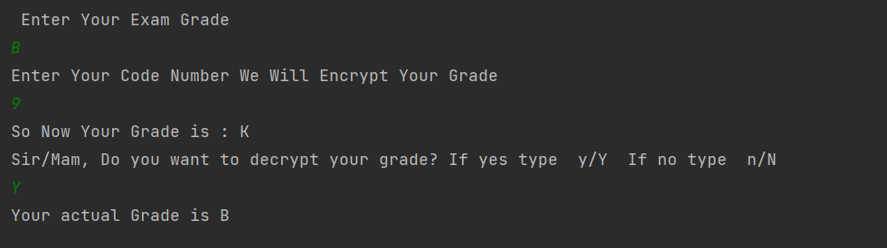

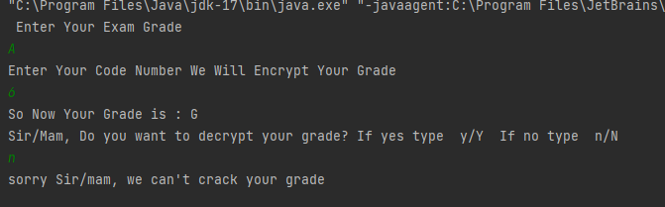

**Python :**

**import click**

**result = input("Please Enter Your Exam Grade: ")**

**code = input("Please Enter Your Encryption Code: ")**

**print("\nNow Your Grade is 'F'")**

**if click.confirm("\nSir/Ma'am, Do You Want to Decrypt Your Grade ? If Yes type 'Y/y' or 'N/n' for No :\n>> ",**

**default=True):**

**print("Your Actual Grade is ", result)**

**else:**

**print("Grade Decryption Aborted")**

**output:**

